”With Christ as our guide, we inspire and thrive”.
Spring Term Newsletter 2026
Year 4
Welcome: Welcome back to the start of a new school term! Swimming lessons will continue up until February half term - children will need to wear their PE kit to school and bring their swimming kit every Friday. Every Monday, Home Learning will be set to be completed by the following Monday, giving the children a week to complete all tasks to the best of their abilities. Please ensure reading books and water bottles are brought into school each day.
Miss Ellison
Religious Education: Branch 3 – Galilee to Jerusalem & Branch 4 – Desert to Garden
Mathematics: Multiplication and Division, Length and Perimeter, Fractions and Decimals
Writing:
- Escape from Pompeii by Christina Balit – Fiction – Historical Narrative
- Koji’s Island by The Literacy Company & Amazing Islands by Sabrina Weiss and Kerry Hyndman – Fiction – Adventure
Composition
To plan writing by discussing the structure, vocab and grammar of similar writing. In narratives, create settings, characters and plot.
Handwriting and Presentation
To continue to develop our handwriting making sure it is legible and joined correctly.
Spoken Language:
To maintain attention and participate actively in collaborative conversations. Children will also participate in discussions, presentations, performances, role play, improvisations and debates

Grammar:
- To use a variety of verb forms correctly and consistently
- To choose noun or pronouns effectively for clarity and cohesion, avoiding unnecessary repetition
- To use fronted adverbials to introduce or connect paragraphs.
Spelling:
- Endings which sound like /ʃən/ spelt -tion, -sion, -ssion, -cian.
- The suffix -ation.
- Beginning to learn word families based on common words.
Reading: This term we will be using the following books in class.
- Volcanoes by Maria Gill
- Ariki and the Island of Wonders by Nicola Davies
Children in Year 4 still benefit from being read to and listened to regularly. Please share books together at home.
Comprehension
- Discuss words and phrases that capture the reader’s interest and imagination
- Identify how language, structure, and presentation contribute to meaning

Science: Sound – How sounds are made and how sound travels, Electricity – building simple series electrical circuits.
Computing: E-Safety – Staying safe online, Data Logging – Microbits, Writing for Different Audiences – Publishing Online.
Geography: European Regions - How are European countries different to the U.K?
History: Romans – How did the Romans influence life in Britain?

Art & Design: Still Life – Compare still life artists and create their own setup, using different materials to recreate it.
Design Technology: Electrical Systems – Simple circuits and switches
Music: The Doot Doot Song - develop technical skills on tuned percussion, Fanfare for the Common Man Spain – investigate how unique music is in creating dramatic effect and atmosphere.
French: Alien Faces and Family & Moving our bodies – To develop vocabulary and French sentences through using key words and phrases.
PSHE: What Can I Be? Who Do I Encounter? What are Hazards in the Home? Mental Health and World Around Me – Forest School, Diversity.
PE / Sports: Swimming Lessons – Water Confidence, Gymnastics – movement and skills, Football – tactics and rules.
Home Learning: Home learning will be set each week on Mondays via Google Classroom. Each week, children will be given:
- 1 Maths task (Paper based or online)
- 1 English task (Paper based or online)
In addition to this, children are expected to continue their daily reading and to practise their times tables on TT Rockstars completing a minimum of 5 minutes per day. Some tasks will be paper based, while others will be set through our online learning platform, IXL. Please make sure all home learning is finished and handed in by the following Monday. If it isn’t completed, your child will be given time at school to complete it. We encourage the children to take responsibility for their own learning and do their best to complete it on time.
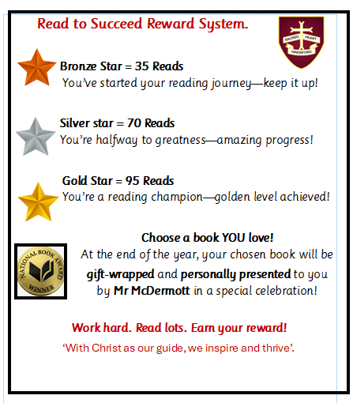
Home Reading: As well as set home learning, your child should also spend time each evening reading for at least 5 minutes. He/she will bring home a book from school. This book must be read as your child will have been assessed and set to match their reading band age. They may also read a book of their own choice from home / the library alongside this if they wish. Their reading record should be filled in every time the child reads at home. The children should make notes about what they have read each week and have this signed by a parent / carer. This will be checked in school weekly.
How you can help at home: Teach your child that failure is a stepping-stone to success and make academic subjects feel relevant to your child. Try to Involve games in learning as much as possible. Where possible, research some areas of learning as this will act as pre learning which will support your child being ready for the lessons.
- Set a routine – choose a regular time for home learning each day.
- Create a quiet space – free from distractions, with everything they need.
- Encourage independence – let them try first, then offer help if needed.
- Talk about learning – ask questions about their reading or maths.
- Daily practice – keep up with reading and times tables on TT Rockstars.
- Stay connected – check Google Classroom/IXL together and contact school if needed.

