Sacred Heart Hindsford R.C. Primary School

Therapeutic Behaviour Policy/Code of Conduct

Policy written by L. Delargy Updated Summer 2023

Accepted by Governors: J. Carter signed (chair)
I. M^{c}Dermott signed (Head)

Shared with staff: date:

By living out our Catholic faith
TOGETHER
we ENCOURAGE
and ACHIEVE
"I have called you by name"

Statement of Intent

At Sacred Heart we endeavour to have a consistent approach to behaviour which is known and followed by all staff and parents and is shared with all members of the school community.
Our approach will be revisited and evaluated each half term.

As a school we are committed to:
- Promoting a culture of praise and encouragement in which all pupils can achieve;
- Promoting self-esteem, self-discipline, proper regard for authority, and positive relationships based on mutual respect;
- Ensuring equality and fair treatment for all;
- Providing a safe environment free from disruption, violence, discrimination, bullying
and any form of harassment;
- Encouraging positive relationships with parents;
- Developing positive relationships with pupils to enable early intervention.

The school acknowledges that behaviour can sometimes be the result of educational needs, mental health issues, or other needs or vulnerabilities, and will address these needs via an individualised graduated response.

To help reduce the likelihood of behavioural issues related to social, emotional or mental health (SEMH), the school aims to create a safe and calm environment in which positive mental health and wellbeing are promoted and pupils are taught to be resilient.

The school aims to promote resilience as part of a whole-school approach using the following methods:
- Culture, ethos and environment – the health and wellbeing of pupils and staff is promoted through the informal curriculum, including leadership practice, policies, values and attitudes, alongside the social and physical environment
- Teaching – the curriculum is used to develop pupils’ knowledge about health and wellbeing
- Community engagement – the school proactively engages with parents, outside agencies and the wider community to promote consistent support for pupils’ health and wellbeing
Where vulnerable pupils or groups are identified, provision will be made to support and promote their positive mental health. The school’s Social, Emotional and Mental Health (SEMH) Policy outlines the specific procedures that will be used to assess these pupils for any SEMH-related difficulties that could affect their behaviour.

Legal framework

This policy has due regard to all relevant legislation and statutory guidance including, but not limited to, the following:
- Education Act 1996
- Education Act 2002
- Equality Act 2010
- Education and Inspections Act 2006
- Health Act 2006
- Voyeurism (Offences) Act 2019
- The School Information (England) Regulations 2008
- DfE (2016) ‘Behaviour and discipline in schools’
- DfE (2021) ‘Keeping children safe in education 2021’
- DfE (2021) ‘Sexual violence and sexual harassment between children in schools and colleges’
- DfE (2018) ‘Mental health and behaviour in schools’
- DfE (2015) ‘Special educational needs and disability code of practice: 0 to 25 years’
- DfE (2013) ‘Use of reasonable force’
- DfE (2018) ‘Searching, screening and confiscation’

This policy operates in conjunction with the following school policies:
- Pupil Code of Conduct
- Social, Emotional and Mental Health (SEMH) Policy
- Complaints Procedures Policy
- Special Educational Needs and Disabilities (SEND) Policy
- Exclusion Policy
- Positive Handling Policy
- Peer-on-Peer Abuse Policy
- Child Protection and Safeguarding Policy
- Anti-Bullying Policy: Pupils

Roles and responsibilities

The governing board has overall responsibility for:
- Ensuring that this policy, as written, does not discriminate on any grounds, including, but not limited to, age, disability, gender reassignment, gender identity, marriage and civil partnership, race, religion or belief, sex and sexual orientation.
- Promoting a whole-school culture where calm, dignity and structure encompass every space and activity.
- Handling complaints regarding this policy, as outlined in the school’s Complaints Procedures Policy.

The headteacher/ deputy headteacher is responsible for:
- The monitoring and implementation of this policy and of the behaviour procedures at the school. This includes the policy’s effectiveness in addressing any SEMH-related drivers of poor behaviour;
- Establishing the standard of behaviour expected by pupils at the school;
- Determining the school rules and any disciplinary sanctions for breaking the rules;
- The day-to-day implementation of this policy;
- Publishing this policy and making it available to staff, parents and pupils at least once a year;
- Reporting to the governing board on the implementation of this policy, including its effectiveness in addressing any SEMH-related issues that could be driving disruptive behaviour.
The mental health lead is responsible for:
- Overseeing the whole-school approach to mental health, including how this is reflected in this policy, how staff are supported with managing pupils with SEMH-related behavioural difficulties, and how the school engages pupils and parents with regards to the behaviour of pupils with SEMH difficulties;
- Supporting behaviour management in line with the Social, Emotional and Mental Health (SEMH) Policy.

The SENCO is responsible for:
- Collaborating with the governing board, headteacher and the mental health lead, as part of the SLT, to determine the strategic development of behavioural and SEMH policies and provisions in the school;
- Undertaking day-to-day responsibilities for the successful operation of the behavioural and SEMH policies to support pupils with SEND, in line with the school’s Special Educational Needs and Disabilities (SEND) Policy;
- Supporting teachers in the further assessment of a pupil’s strengths and areas for improvement and advising on the effective implementation of support.

Teaching staff are responsible for:
- Planning and reviewing support for pupils with behavioural difficulties in collaboration with parents, the SENCO and, where appropriate, the pupils themselves;
- Aiming to teach all pupils the full curriculum, whatever their prior attainment;
- Planning lessons to address potential areas of difficulty to ensure that there are no barriers to every pupil achieving their full potential, and that every pupil with behavioural difficulties will be able to study the full national curriculum;
- Being responsible and accountable for the progress and development of the pupils in their class.

All members of staff, including teaching and support staff, and volunteers are responsible for:
- Adhering to this policy;
- Supporting pupils in adhering to this policy;
- Promoting a supportive and high-quality learning environment;
- Modelling high levels of behaviour;
- Being aware of the signs of behavioural difficulties;
- Setting high expectations for every pupil;
- Being aware of the needs, outcomes sought, and support provided to any pupils with specific behavioural needs;
- Keeping the relevant figures of authority up-to-date with any changes in behaviour. The relevant figures of authority include:
  - SENCO.
  - Headteacher.
  - Deputy headteacher.
  - Subject leader.
- As authorised by the headteacher/deputy headteacher, disciplining pupils who display poor levels of behaviour. This responsibility includes the power to discipline pupils even when they are not in school or in the charge of a member of staff.

Pupils are responsible for:
- Their own behaviour both inside school and out in the wider community;
- Reporting any unacceptable behaviour to a member of staff.

Parents are responsible for:
- Supporting their child in adhering to the school rules;
- Informing the school of any changes in circumstances which may affect their child’s behaviour.
Aims and Implementation:

Positive recognition, importance and sense of belonging.

Class Dojo
At Sacred Heart we use Class Dojo in supporting children to adhere to the Therapeutic Behaviour Policy.
The appropriate year group class page will be displayed on the IWB and each child will have their own image which is instantly recognisable.
All children will begin on 3 points as we expect all our children are able recognise the importance of Sacred Heart TEAM ethos.

TOGETHER EVERYONE ACHIEVES MORE – all children are ready to learn, are
respectful of the needs of others and all ensure a classroom environment which
is safe and conducive to learning.

Expectations
At Sacred Heart we recognise that children need to know what is expected of them if they are to be successful. Clear expectations help to create a positive learning environment and simple rules and routines set out clear expectations.
A consistent empathetic approach is necessary to ensure expectations are the same for the majority of children. (This will be adapted as appropriate for children with additional needs or as deemed appropriate as a short-term intervention by the class teacher.)
Each classroom has the school Code of Conduct (ethos) clearly displayed in both photographs and words to reinforce expectations.
We endeavour to catch and praise all good behaviour using gestures, facial expressions and actions to emphasise our words.

Rewards
Class Dojo is monitored by Deputy Headteacher and individual TEAM stickers are awarded each half term for a TEAM Certificate. A certificate is also sent home to parents/carers to keep them updated with children’s attitude and behaviour.
.
Autumn 1 – TEAM sticker 1
Autumn 2 – TEAM sticker 2
Spring 1 – TEAM sticker 3
Spring 2 – Bronze Award
Summer 1 – Silver Award
Summer 2 – Gold Award

Recognition Board
At Sacred Heart we recognise children who go over and above expectations e.g. exceptional work ethic, determination to succeed, awareness of the needs of others etc.
Each classroom has their own version of a recognition board:
- Displayed in each classroom;
- Children’s names added when being recognised for going over and above everyday expectations i.e. code of conduct;
- Name displayed and changed on a weekly basis;
- Children who are recognised for effort not achievement;
- Celebrated regularly and particularly when all children get their names on the board. (Loud and proud.)

Staff should triangulate i.e. ensure other members of staff know about the children on the board so that they can also recognise their effort and can comment on it in afternoon topics.
A recognition board is also to be placed in the dining hall – to maintain high expectations where staff are able to choose 3 children within each key stage.

Rewards for recognition:
- Hot Chocolate Friday (or a suitable alternative where necessary).

Sanctions
At Sacred Heart, children choose to lose their class dojo points by not adhering to the school ethos.
If they lose their 1st dojo point – Adults speak to the child and recognise difficulties without blame:
- Use the child’s name and gain eye contact;
- Ask for the behaviour you want;
- Remind them what they should be doing;
- Remind them of the rewards and sanctions;
- Mean what you say and carry it through.

If they lose their 2nd dojo point - Adults discuss the loss of the point privately using firm but empathetic (non- confrontational) language:
- I noticed you are having trouble with …
- It was the rule about…
- I am listening, but I want you to…
- I understand that you may be cross but …
- You have chosen to lose your premiership point because …
- Do you remember when …
- That’s what I need to see today;
- Thank you for listening.

If they lose their 3rd dojo point - Adults give the child time to consider their actions by losing a portion of their break time for a Restorative Conversation with a member of SLT.
- What happened?
- What were you thinking at the time?
- What have you thought since?
- How did this make people feel?
- Who has been affected? How?
- What should we do to put things right?
- How can we do things differently in future?

Monitoring and Support

B1 – Teachers reset and update class and playground dojo daily.
B2 – Consistent green/ less than 90% (not recovered within 2 weeks) – Speak to parents and children complete a reward (KS1 and LKS2) or behaviour chart (Key Stage 2).

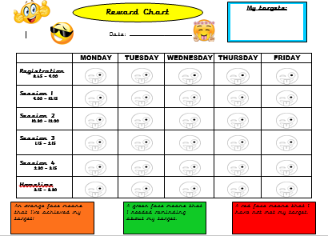

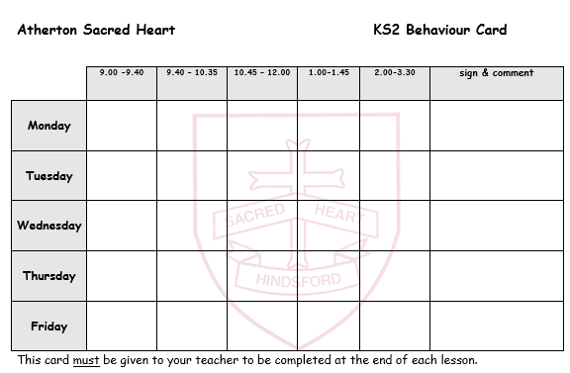

B3 – Consistent red/ serious concerns – Children complete a behaviour chart and staff will monitor behaviour using the class log. A parent conference will be arranged with the class teacher and a member of the Senior Leadership Team to discuss ways forward.

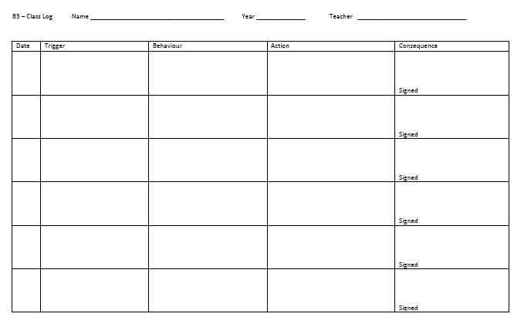

Parental Support

Without parental support, improving behaviour is more difficult and a much slower process. Children pick up when carers question what their teacher is saying or believe that it must be someone else’s fault. Of course, all children can have a bad day and all staff can make mistakes but judgements about behaviour are made over a period of time and by looking at patterns of behaviour rather than an off day or single event.

Sometimes a child may underachieve for more complicated reasons and might be going through a ‘difficult’ time. We understand this and are sensitive to personal circumstances. By working together, we can explore and hopefully find a resolution or put measures in place.
At Sacred Heart we appreciate your ongoing support with behaviour, attitude to learning and motivating your child to achieve the best that s/he can every day in school.

If you do have any concerns or queries regarding behaviour please contact the school office.

Power to use reasonable force - Positive Handling, Physical Invention

All members of staff are regularly updated regarding government guidance on the use of Reasonable Force. The actions of staff will always be in the best interest of the child and are in line with government guidelines on the Use of Reasonable Force. The decision on whether or not to physically intervene is down to the professional judgement of the staff member concerned and should always depend on the individual circumstances as to whether it is necessary, reasonable and proportionate to the level of risk. If there is foreseeable risk, then a risk assessment must be undertaken and a plan created to reduce the level of risk – this could be a Positive Handling Plan (PHP) or a Positive Behaviour Support Plan (PBSP)

Reasonable force can be used to:
- remove disruptive children from the classroom where they have refused to follow an instruction to do so;
- prevent a pupil behaving in a way that disrupts a school event or a school trip or visit;
- prevent a pupil leaving the classroom or school site where allowing the pupil to leave would risk their safety or lead to behaviour that disrupts the behaviour of others;
- prevent a pupil from attacking a member of staff or another pupil, or to stop a fight in the playground;
- restrain a pupil at risk of harming themselves through physical outbursts.

Reasonable force cannot be used
- as a punishment – it is always unlawful to use force as a punishment.

Rules and Routines

Rolling Registration Morning Carousel
- Children enter their classroom quietly and are greeted by the adults.
- Morning Carousel activities are displayed pictorially or in the form of a timetable within class (dependent on age and ability of the children).
- Activities are begun immediately and independently and children are expected to work quietly and sensibly.
- Appropriate music, in keeping with the Catholic Ethos of the school, is to be played throughout the morning registration carousel.

Lessons
Children enter the classroom quietly when greeted by the teacher or other adult.

Begin each lesson promptly:
- Time and task
- Resources
- Outcomes (WILF)
- Grouping
- Stop

A countdown from 5 informs the children it is time to stop, put down equipment and to look and listen to the adult. The countdown is punctuated with positive reinforcement.
Children should always move around or leave the classroom in groups to ensure the classroom remains safe and calm.

Break Time Routines
The playground is divided in to 4 zones:

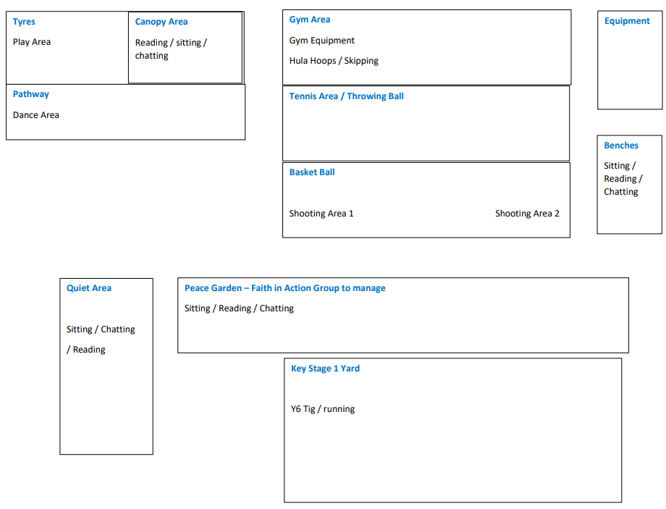

Zone 1 – Tyre/ Canopy/ Pathway
Zone 2 – Gym/Tennis/Equipment/Benches
Zone 3 – Basketball/ Peace Garden/ Quiet Area
Zone 4 – Year 6 Tig/Running

Key Stage 1

Timings
- Reception - 10.45am – 11.00 am and 2.15 pm – 2.30 pm
- Year 1 – 10.45am – 11.00 am and 2.15 pm – 2.30 pm
- Year 2 – 10.45am – 11.00 am and 2.15 pm – 2.30 pm

An adult (teacher or TA as appropriate) escort children to the toilet and will support children as they wash/sanitise their hands and collect coats.
Children will then return to class to create a ‘lovely line’.

Children must be supervised at all times (particularly when visiting the toilets).

Any adult who is on playground duty, needs to be present on the playground before the children leave the classroom to go outside.

When ready, the children will be supervised as they exit through classroom door and as they walk onto the playground and play area.

The school field will also be included into the rota system when it is safe to do so.

Children will be supervised as they return to class through main hall door where they will sanitise their hands and wipe their feet before walking along the corridor and return to class.

Key Stage 2

Timings
- Year 3 - 10.15 am – 10.30 am and 1.45 pm – 2.00pm
- Year 4 - 10.20 am – 10.35 am and 1.50 pm – 2.05pm
- Year 5 - 10.15 am– 10.30 am and 1.45 pm – 2.00 pm
- Year 6 - 10.20 am – 10.35 am and 1.50 pm – 2.05pm

An adult (teacher or TA as appropriate) will support children as they sanitise their hands and collect coats. Children will then return to class to create a ‘legendry line’.

Children must be supervised at all times (particularly when visiting the toilets and when in the cloakroom).

Adults must escort the children to the corridor and encourage ‘legendry lines’ and ‘wonderful walking’. Children walk on the left and adults insist on quiet, indoor voices.

Children should be supervised as they walk out, to the appropriate zone, sensibly whilst maintaining ‘legendry lines’ and ‘wonderful walking’. Staff should remain in corridors until all the children have been escorted outside.

The school field will also be included into the rota system when it is safe to do so.

Behaviour Management on the Playground
- Adults position themselves where they have an overview of the whole of their zone;
- Any outdoor play equipment needs to be managed effectively e.g. children line up and take turns;
- Children are not allowed to play in Key Stage 1 outdoor classroom during breaktime;
- Adults do not engage with one particular group of children (we are not their ‘playmates’
we are there to supervise all children);
- Adults refrain from holding hands etc. with children unless used as a strategy for
behaviour management;
- Adults must intervene and manage behaviour issues immediately. Ensure messages are
understood by the children (children have to be aware that adult’s instructions are to be respected and followed without questioning);
- Any disrespectful language or actions need to be addressed by the adults on the yard
and reported to SLT (when deemed appropriate);
- For any minor behaviour issues, the children remain by the side of the adult for the
remainder of break time and there is a loss of a playtime Dojo point;
- Any major issues e.g. danger of injury to themselves or others, then children need to be
instructed to go inside and report to a member of the SLT.

End of Break Time Routines

Ring bell 5 minutes before the end of break to ensure all children line up and are back into class on time and to begin their next session.

When the children hear the first bell, they must stop and stand still and when they hear the second bell children must walk to their line. Children who do not walk will have to go back and try again.

Children to be supervised as they return into school, through main hall door, where they will sanitise their hands and wipe their feet before walking along the corridor and returning to class.

TA’s should manage the legendry lines and escort the children back into school, insisting on wonderful walking. A member of staff (teacher where possible) should meet their own class of children in the corridor and escort the children back to the classroom.

After break, as the children return to classes, all staff need to be on alert to listen for corridor noise and intervene wherever and whenever appropriate.
Staff should always be present and ready to welcome children back after breaks.
Children enter class, when invited to do so by the adult, settle quickly and be ready to learn.

Year 6 corridor monitors can choose 3 children to receive recognition notes.

Dinner Time Routines

Timings

Key Stage 2
11.45 until 12.15 - 2 sittings in rotation Year’s 3 and 5 / 4 and 6

2 adults will be in the dinner hall whilst one adult is outside to supervise the children.
Children who are on first sittings use the right-hand side of the stairs to enter the hall and children who are going outside, use the left-hand side. This should alleviate congestion.

As the children enter the hall, fill the tables in order, from the window to door and then from the front to the back. (Children do not choose their own table but can choose which seat in order to be with a friend.)

As one table finishes their lunch, ensure they tidy their table and then send them out, the outdoor staff can then send in a group to replace them.
When a new group of children arrive in the hall, they can then fill up the tables as before.
The front tables should be cleared first and wiped ready for key stage 1.

Key Stage 1

Children begin lunchtime outdoors and then start to go into the hall at 12.30.

As with Key Stage 2, the children enter the hall and fill the tables in order from the window to door and then from the front to the back. (Children do not choose their own table but can choose which seat to be with a friend.)

To ensure all Key Stage 1 staff and children are ready for class at 1.15, clean the tables and leave for dinner staff to fold and put away.

Behaviour Management in the Dinner Hall

An adult (teacher or TA as appropriate) will support children as they sanitise their hands and collect coats. Children will then return to class to create a ‘legendry line’.

Children must be supervised at all times (particularly when visiting the toilets and when in the cloakroom).

Adults must escort the children into the corridor and encourage ‘legendry lines’ and ‘wonderful walking’ as they walk to the hall.
Children walk on the left and adults remind children of indoor voices.

- When invited, the children enter the hall quietly and walk in one straight line to the benches to wait to be served. Any children not entering according to the expectations should be asked to try again.
- Noise levels need to be managed by the adults on duty. (Indoor voices).
- Use 5 – 0 countdown and insist all children face the adult before reminding them about appropriate voices.
- Children remain in their designated seat until they have attracted the attention of an adult.
- Implement behaviour policy, Steps 1, 2 and 3, for any children who display unacceptable behaviour e.g.
- table manners
- disrespectful to children or adults
- out of seat without permission
- loud inappropriate voice or silly noises
- health and safety concerns e.g. running, use of cutlery

